StudySync: MMDC Student Groupmate Matching System - Component Diagram
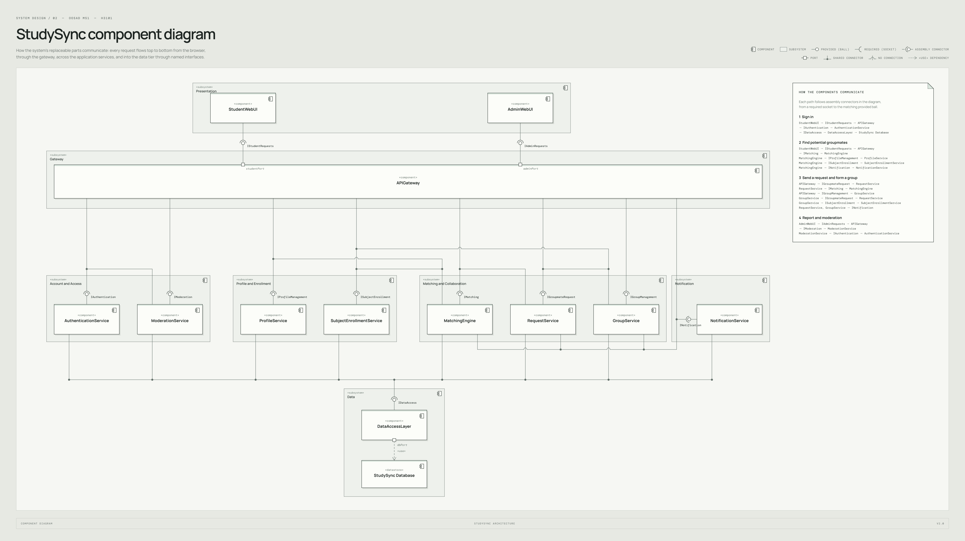
Editable source: StudySync_Component_Diagram.puml. Native editable version: StudySync UML Diagrams (Figma).

